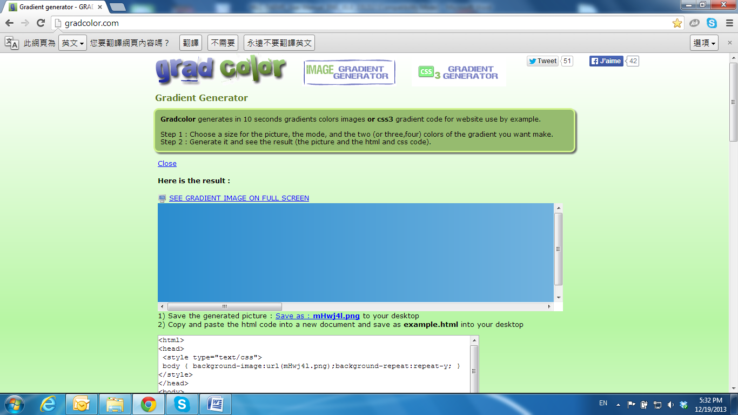

System

Click 83-003 to get into the administration page. Click 83-007 to go back to the live video page.

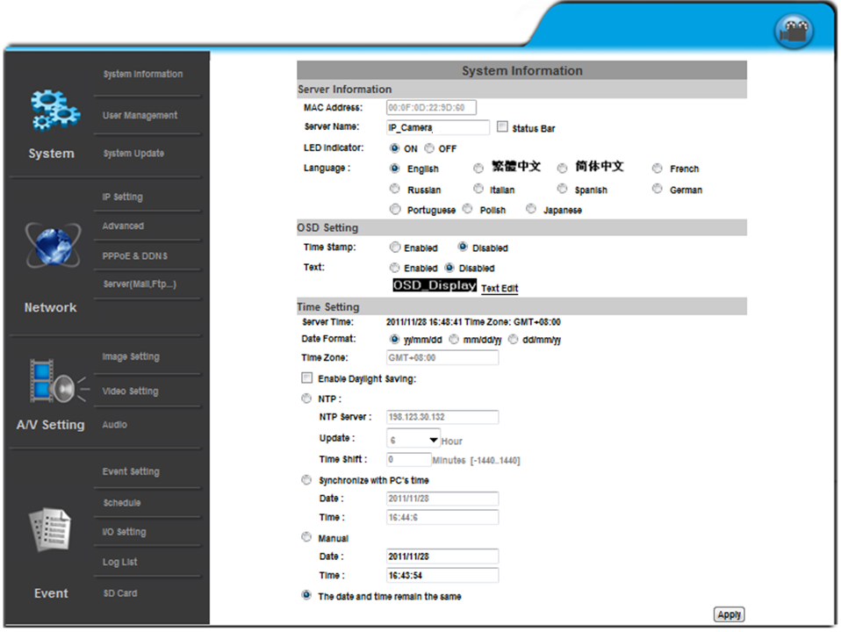

1. **System Information**
   * 1. Server Information: Set up the camera name, select language, and set up the camera time.
        1. Server Name: This is the Camera name. This name will be shown on the IP Installer.
        2. Select language: English, Traditional Chinese, and Simplified Chinese can be selected. When it changes, it will show the following dialogue box to confirm the language changing.

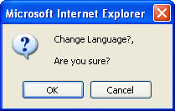

* + 1. OSD Setting: Select a position where the date & time stamp / text are shown on the screen.

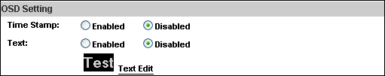

Moreover, click **Text Edit** for changing the OSD content, including text size and alpha. Finally, click the Upgrade button to keep the settings.

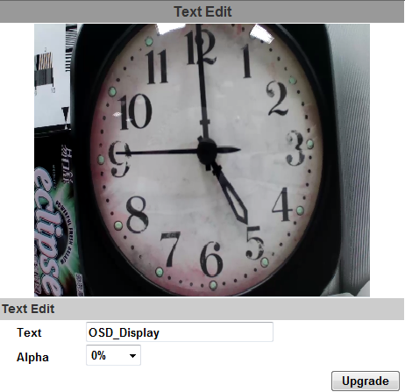

* + 1. Server time setting: Select between the options **NTP**, **Synchronize with PC’s time**, **Manual**, **The date and time remain the same** for setting the time.

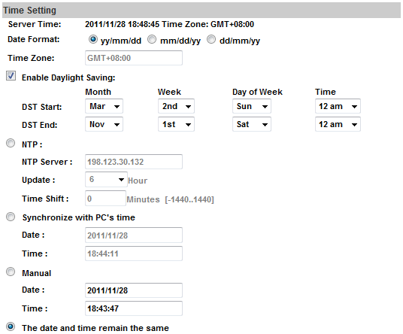

1. **User Management**

The IP Camera supports three different users: **administrator**, **general**, and **anonymous** user.

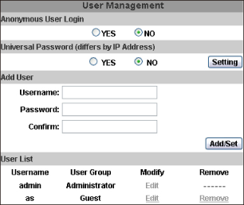

**a. Anonymous User Login:**

Select **Yes** for allowing everybody to watch live video without username and password. However, if you try to enter the configuration page the camera will ask you to key-in the username and password.

Select **No** for requiring a username and login to access the camera.

**b. Universal Password:**

Select **Yes** for allowing login to this IP Cam by universal password. Please refer to **Universal Password** chapter for more explanations. Select **No** for disabling universal password.

**c. Add user**

Type the user name and password, then click **Add/Set**. The guest user can only browse live video page and is not allowed to enter the configuration page.

**d. Click “edit” or “delete” in the user list to modify them. The system will ask you to key-in the password in the pop-up window before you edit the user information.**

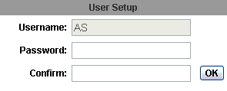

1. **System update**

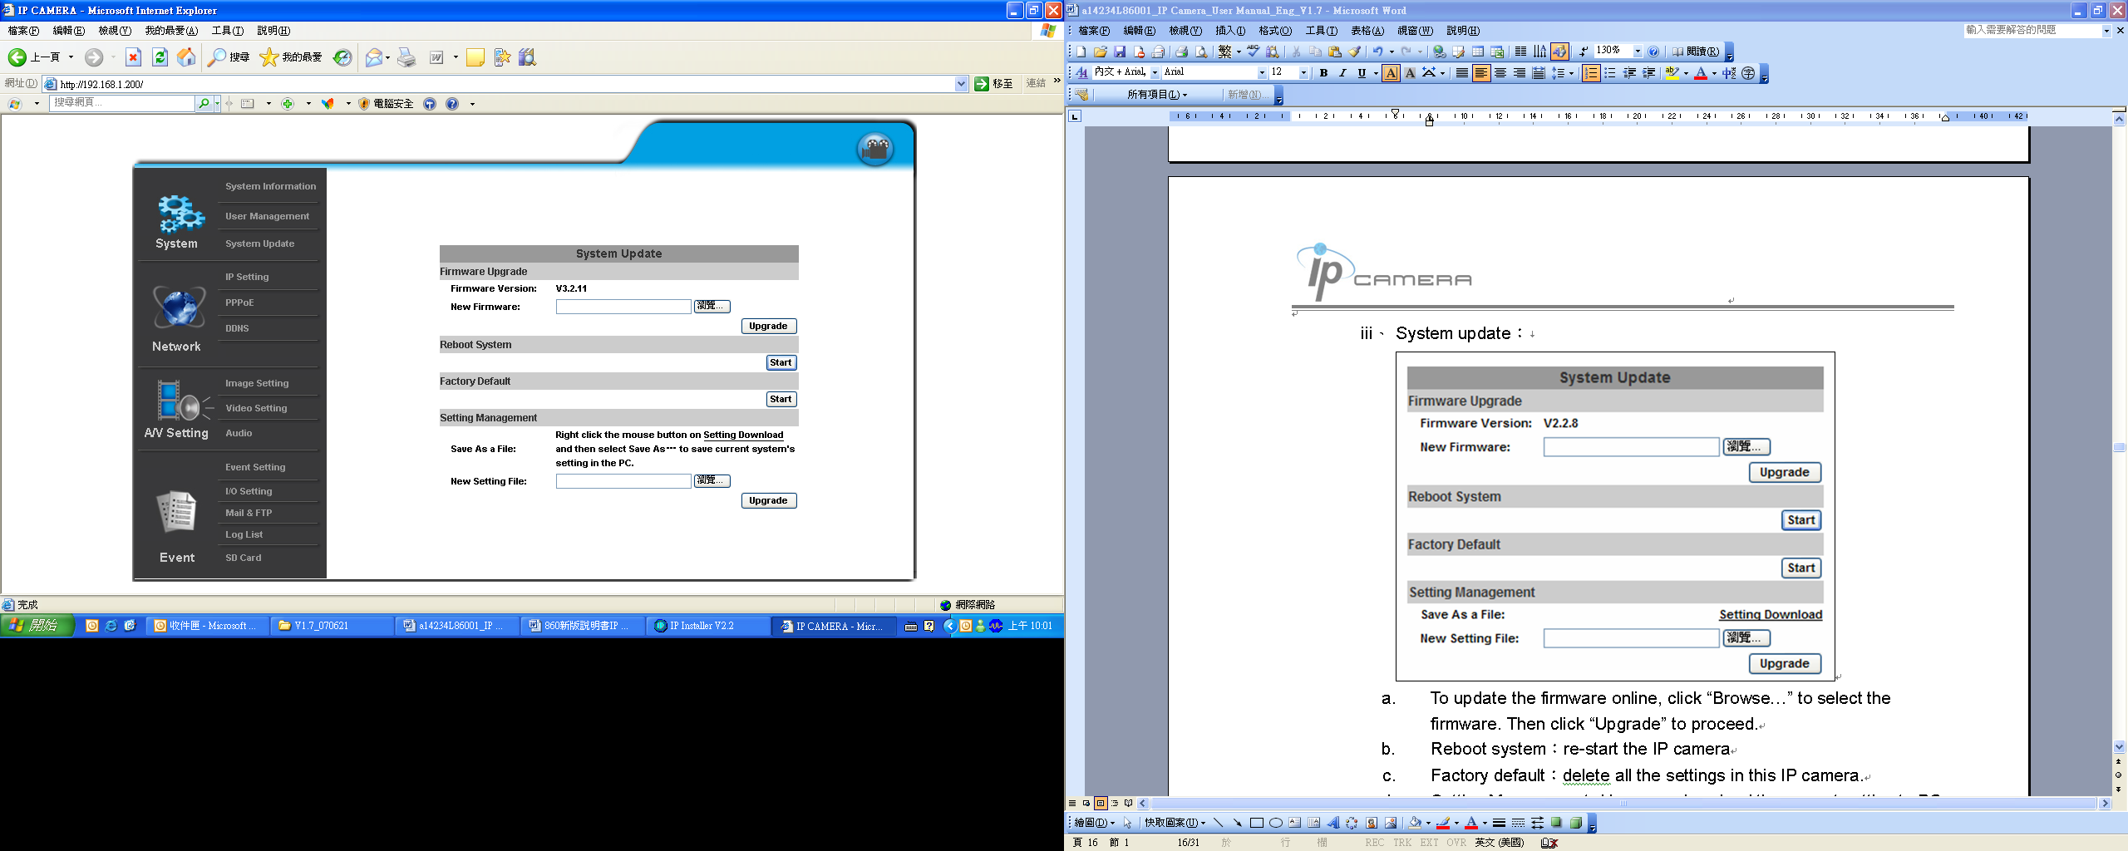

1. To update the firmware online, click **Browse…** to select the firmware. Then click **Upgrade** to proceed.
2. Reboot system: re-start the IP camera
3. Factory default: delete all the settings of this IP camera.
4. Setting Management: The user can download the current settings to PC, or upgrade from previous saved settings.
   * + 1. Settings download:

Right-click the mouse button on Setting Download 🡪 Select **Save AS…** to save current IP Camera settings in PC 🡪 Select saving directory 🡪 Save

* + - 1. Upgrade from previous settings

Browse 🡪 search previous settings 🡪 open 🡪 upgrade 🡪 Settings update confirm 🡪 click **index.html**. for returning to the main page.